Proposed 2004-2005 Budget
Student Council
University of Virginia
Appropriations Committee
to be used for spring 2004 process

TYPEOVER BLUE TEXT ONLY
Outdoors at UVA
PO Box 400444 Newcomb Hall

On my honor as a student, the enclosed information is accurate to the best of my knowledge.

Co-President: _________________
Case Taintor
423-240-9577
outdoors-officers@virginia.edu

co-President: _________________
Thiago ize
243-0442
outdoors-officers@virginia.edu

Appropriations committee representative:
Eli dejarnette
__________________________

FOR COMMITTEE USE ONLY:
Total Expenditures: [$0.00] Total Self-Generated Revenue: [$0.00] Support: [$0.00]
Overview of Events:

Year in review: 2003 - 2004
Adventure | Location | Date
Franklin climbing trip for advanced climbers | Franklin crag | Aug 30, 2002
Waterfall Hiking & Camping: Cedar Run & Whiteoak Canyon, Shena | Cedar Run & Whiteoak Canyon | Aug 31, 2002
Announcement: Search & Rescue Info Session | Ruffner Hall room G004C | Sep 4, 2002
Climbing trip / Belaying Workshop | Little Stony Man Cliffs | Sep 7, 2002
mountain biking / trail maintenance | walnut creek | Sep 7, 2002
Announcement: Student Environmental Action Cookout | The Dell | Sep 7, 2002
High Ropes Course at UVa Poplar Ridge | Poplar Ridge | Sep 8, 2002
Easy Road Biking | The countryside of Cville | Sep 8, 2002
Announcemnt: Volunteer to Help Kids Learn about the Environment | Newcomb Hall room 389 | Sep 10, 2002
Climbing trip / Belaying Workshop | Raven's Roost | Sep 14, 2002
Appalachian Trail workday | shennandoah national park | Sep 14, 2002
VA Beach Blowout! Sun & Sand, Paddling, Hiking, Biking, SCUBA, | VA Beach 1st Landing State Park | Sep 14, 2002
Indoor Climbing/Learning Ratings | Rocky Top Gym | Sep 20, 2002
River Stewardship Day | Williamsburg Area | Sep 21, 2002
AT/Shenandoah Nat'l Park long day hike | Somewhere at UVa, probably AFC | Sep 22, 2002
James River Tubing | James River Reeling and Rafting | Sep 22, 2002
Intro to Pro/toprope climbing | Hidden Rocks | Sep 28, 2002
Backpacking for Beginners & More Experienced As Well | Laurel Fork | Sep 28, 2002
Skydiving | Orange, skydive | Sep 29, 2002
Intro to Trad / Toprope climbing | Seneca Rocks | Oct 4, 2002
Appalachian Trail Intermediate Backpacking | Appalachian Trail | Oct 5, 2002
The Great Smoky Mountains Hiking Extravaganza | Great Smoky Mountains National | Oct 5, 2002
Trad/Toprope climbing & knot workshop | Goshen Pass | Oct 12, 2002
Trail Maintenance for the Nature Conservancy | Fortunes Cove Nature Preserve | Oct 12, 2002
Bouldering | Moormon's Rock | Oct 16, 2002
Horseback Riding at Master's Inn Retreat | Master's Inn Retreat | Oct 19, 2002
Class V White Water Rafting | Gauley River West Virginia | Oct 19, 2002
Overnight Backpacking Trip to Saint Mary's Wilderness | Saint Mary's Wilderness | Oct 19, 2002
Indoor Climbing | Peak Experiences | Oct 19, 2002
Ride in the Countryside of Cville | The countryside of Cville | Oct 20, 2002
Bouldering | Moormon's Rock | Oct 23, 2002
Toprope climbing + rappelling workshop | Little Stony Man Cliffs | Oct 26, 2002
Primitive Tools and Survival | Monroe Hill House | Oct 28, 2002
New River Gorge Climbing | New River Gorge | Nov 1, 2002
Horseback Ride at Master's Inn | Master's Inn Retreat | Nov 2, 2002
Hiking at Devil's Marbleyard | Devil's Marbleyard | Nov 2, 2002
Setting toprope workshop / toprope climbing | Raven's Roost | Nov 9, 2002
Backpacking and Caving: Riprap Hollow, SNP | Riprap Hollow, Shenandoah Park | Nov 9, 2002
fall foliage tour – dayhiking | shennandoah national park | Nov 9, 2002
5K for American Heart Association | AFC | Nov 10, 2002
Climbing Indoors | ACAC Rocks | Nov 15, 2002
Caving | Cave | Nov 16, 2002
Old Rag Day Hike | Old Rag | Nov 16, 2002
One Night Backpacking Trip to Saint Mary's Wilderness | Saint Mary's Wilderness | Nov 16, 2002
Leonids Meteor Watching From Humpback Rocks | Humpback Rocks | Nov 19, 2002
Climbing Indoors | Peak Experiences | Nov 24, 2002
Snow, Waterfall, Awesome View HIKE | Shenandoah Nat'l Park | Dec 7, 2002
Caving | Cave | Dec 8, 2002
Wintergreen Ski / Snowboard Discount | Wintergreen | Jan 10, 2003
Rock Climbing indoors | Peak Experiences | Jan 18, 2003
Frozen Waterfall Hike: Whiteoak Canyon | Shenandoah Nat'l Park | Jan 19, 2003
climbing at rockytop gym | Rocky Top Gym | Jan 22, 2003
Rock Climbing indoors | Peak Experiences | Jan 26, 2003
Climbing indoors @ Rocky Top | Rocky Top Gym | Jan 30, 2003
Ski/Snowboard Extravaganza at Snowshoe, WVa | Snowshoe Mountain | Jan 31, 2003
Rocky Top Climbing | Rocky Top Gym | Feb 6, 2003
Wilderness First Aid | Somewhere at UVa, probably AFC | Feb 8, 2003
Rock Climbing indoors | Peak Experiences | Feb 8, 2003
Wintergreen Snow Tubing!! | Wintergreen | Feb 13, 2003
Thursday Climbing | Peak Experiences | Feb 13, 2003
rock climbing | Rocky Top Gym | Feb 15, 2003
Snow Football!!! | nameless field | Feb 17, 2003
First Annual College Climbing Competition | Virginia beach indoor rock clim | Feb 21, 2003
5K for UVa Cancer Center | Whitehead and Stadium Rd | Feb 22, 2003
Wintergreen Evening Ski | Wintergreen | Feb 22, 2003
Caving | Breathing Cave | Feb 23, 2003
Florida Spring Break: Backpacking, Manatees, Beach! | Florida | Feb 28, 2003
Breathing Cave | Breathing Cave | Mar 1, 2003
White Mountains, NH Spring Break Trip! Ski/Hike/Camp! | White Mountain National Park | Mar 1, 2003
Spring Break climbing at Red Rocks | Red Rocks Canyon | Mar 2, 2003
Bouldering | Moormon's Rock | Mar 13, 2003
Social Adventure: 5 VERMONSTERS: 100 Scoops Ben&Jerrys IceCream | Ben & Jerry's | Mar 15, 2003
Old Rag Sunday Hiking or/and climbing | Shenandoah Nat'l Park | Mar 16, 2003
Volunteer Gardening at Bog in Washington Park | Washington Park in Cville | Mar 16, 2003
Kayak Roll Class: Learn how to flip yourself back up! | AFC | Mar 18, 2003
Bouldering | Moormon's Rock | Mar 20, 2003
peak climbing | Peak Experiences | Mar 20, 2003
Intro to White Water Kayaking | Rivanna River | Mar 21, 2003
Outdoors Rock climbing | Franklin crag | Mar 22, 2003
Run/Walk For Life 5K | Newcomb Hall Plaza | Mar 22, 2003
Backpacking Trip to (1/3 of) Saint Mary's Wilderness Trail | Saint Mary's Wilderness | Mar 22, 2003
Ride in the Countryside of Cville | The countryside of Cville | Mar 23, 2003
O’Hill Trail Riding | O'Hill | Mar 27, 2003
indoor rock climbing Thursday | Peak Experiences | Mar 27, 2003
Intro to White Water Kayaking II | Rivanna River | Mar 29, 2003
Volunteer Gardening at Bog in Washington Park | Washington Park in Cville | Mar 29, 2003
Old Rag Day Hike | Old Rag | Mar 30, 2003
Afternoon hike to Humpback Rocks | Humpback Rocks | Mar 30, 2003
Charity Adventure-Relay for Life! | Fountaine Research Park's Depar | Apr 4, 2003
Just For Kicks Charity Adventure Soccer Tournament | Carr's Hill Field | Apr 4, 2003
Sport Climbing | New River Gorge | Apr 4, 2003
Advanced Kayaking to WV | New River Gorge | Apr 4, 2003
Marshals Cave | Marshall's Cave | Apr 5, 2003
Trail Maintenance/Riding at Walnut Creek Park | walnut creek | Apr 5, 2003
Chill Backpacking Trip (6.5 mi one day, maybe 5.5 the next day) | Cold Mountain / Mount Pleasant | Apr 5, 2003
Pick out a Highway to Adopt and Go Hiking | Humpback Rocks | Apr 10, 2003
Bat Cleaning in Breathing Cave | Breathing Cave | Apr 12, 2003
tree planting w/Nature Conservancy | Rivanna River | Apr 12, 2003
Intermediate-advanced White Water Kayaking | James River - Balcony Falls | Apr 12, 2003
Sugar Hollow Hiking/Swimming | Sugar Hollow Reservoir | Apr 17, 2003
Potluck and Princess Bride | Baron and Nathaniel's House | Apr 17, 2003
Rocky Mount loop camping! | shennandoah national park | Apr 18, 2003
Earth Day Hike at Fortunes Cove | Fortunes Cove Nature Preserve | Apr 19, 2003
Trail Riding at Walnut Creek Park | walnut creek | Apr 23, 2003
Intermediate White Water Kayaking | James River - Balcony Falls | Apr 26, 2003
mini-Woodstock Acoustic Social Adventure | Oakley Farm | Apr 26, 2003
Celebration Backpacking (~6 miles total) | Cold Mountain / Mount Pleasant | Apr 29, 2003
Swimming at Sugar Hollow | Sugar Hollow Reservoir | Apr 30, 2003
Kayak Outfitting/Repair | Matt Rosefsky's apartment | Apr 30, 2003
Announcement: Greenlight Environmental Volunteering Programs | Madison House | May 1, 2003
Study Break Day Hike! | Undecided | May 3, 2003
The Rivanna River is… | Rivanna River | May 20, 2003
Intermediate White Water Kayaking | James River - Balcony Falls | Jun 1, 2003
Kayaking in Richmond (Pony Pasture run) | James River - Richmond | Jun 5, 2003
Hiking/Swimming White Oak Canyon | White Oak Canyon Trail | Jun 14, 2003
sport climb at the New River Gorge | New River Gorge | Jun 20, 2003
Climbing at Peak Experiences | Peak Experiences | Jun 21, 2003
kayaking the middle James | James River - Balcony Falls | Jun 22, 2003
climbing at the new river gorge | New River Gorge | Jun 27, 2003
Intro to White Water Kayaking – Learning the Basics | Beaver Creek | Jun 29, 2003
Kayaking the Rivanna | Rivanna River | Jul 8, 2003
kayak roll class | Beaver Creek | Jul 18, 2003
kayaking the James in Richmond | James River - Richmond | Jul 19, 2003
Refreshing Hike to Natural Waterslide, Waterfalls & Swim Holes | Shenandoah Nat'l Park | Jul 19, 2003
Mountain Biking at Sherando Lake | Sherando Lake | Jul 20, 2003
Balcony Falls | James River - Balcony Falls | Jul 23, 2003
Backpacking at Dolly Sods | Dolly Sods Wilderness | Jul 25, 2003
climb, swim and jump | New River Gorge | Jul 26, 2003
Caving | Marshall's Cave | Aug 3, 2003
Beginner-intermediate WW kayaking | James River - Balcony Falls | Aug 5, 2003
PARTY!! | Dave Clark's house | Aug 16, 2003
Hiking, climbing at Seneca rocks | Seneca Rocks | Aug 17, 2003
Sunset Hike in Shenandoah National Park | Shenandoah National Park | Aug 28, 2003
Advanced Climbing Trip | Franklin crag | Aug 30, 2003
Whitewater Workshop/Roll Class | Beaver Creek | Aug 30, 2003
climbing basics workshop/ trad climbing | Little stony man cliffs | Aug 31, 2003
Highway Pickup and Sugar Hollow Swimming | Adopted Highway then Sugar Hollow | Aug 31, 2003
Paddling through downtown Richmond | James River - Richmond | Sep 3, 2003
Waterslides Hike | Shenandoah National Park | Sep 6, 2003
Advanced Climbing Trip Redux | Franklin crag | Sep 6, 2003
Caving in Cove Island | Cove Island | Sep 7, 2003
climbing basics workshop/ trad climbing | Little stony man cliffs | Sep 7, 2003
Trail Riding at Walnut Creek Park | Walnut Creek Park | Sep 10, 2003
Canoe w/Community Attention | rivanna river | Sep 12, 2003
Great Dismal Swamp Sea Kayaking | Great Dismal Swamp | Sep 12, 2003
Beginner and Intermediate Climbing | Little stony man cliffs | Sep 13, 2003
Backpacking at WV Border | Little Sluice Mountain and Cedar Creek | Sep 13, 2003
Mountain Biking at Sherando Lake | Sherando Lake | Sep 14, 2003
Intro to White Water Kayaking -- Learning the Basics | Beaver Creek | Sep 14, 2003
Kayaking the James in Richmond | James River - Richmond | Sep 16, 2003
Potluck! | Sophie Johnson's house | Sep 17, 2003
beginner/advanced climbing at Bozoo rocks | Bozoo Rocks | Sep 20, 2003
Virginia Beach EXTRAVAGANZA! Sun & Sand, Scuba, Hiking, Surf Kayaking, and Biking! | First Landing State Park | Sep 20, 2003
Ol' Rag: post hurricane day hike | old rag | Sep 20, 2003
Intro kayaking down the Rivanna | Rivanna River | Sep 21, 2003
Intermediate white water kayaking | James River - Glasgow to Snowden (Balcony Falls) | Sep 21, 2003
Beginner-Intermediate WW Kayaking | James River - Glasgow to Snowden (Balcony Falls) | Thu Sep 25, 2003
Canoe w/Community Attention - take two | rivanna river | Fri Sep 26, 2003
sport climbing/how to lead workshop | Franklin crag | Sat Sep 27, 2003
Caving | Breathing Cave | Sun Sep 28, 2003
Trail Clean-Up at Walnut Creek Park | Walnut Creek Park | Thu Oct 2, 2003
Two-night Intermediate Backpacking Trip to Dolly Sods! | Dolly Sods | Fri Oct 3, 2003
Beginner and Intermediate Climbing | Little stony man cliffs | Sat Oct 4, 2003
easy mountain biking - saturday morning | Walnut Creek Park | Sat Oct 4, 2003
Learning how to paddle and roll a white water kayak | Walnut Creek Park | Sat Oct 4, 2003
Mountain Biking at Sherando Lake | Sherando Lake | Sun Oct 5, 2003
Rock climbing is so much fun! The Red River Gorge | The Red River Gorge | Fri Oct 10, 2003
Appalachian Trail Intermediate Backpacking | Appalachian National Scenic Trail | Sat Oct 11, 2003
Fall Break Afternoon Hike | Undecided | Sun Oct 12, 2003
Canoe w/Community Attention - Wed 15th | rivanna river | Wed Oct 15, 2003
Ice Cream Social: The Vermonster! | Ben & Jerry's at Barracks Road | Thu Oct 16, 2003
Sierra Student Coalition Conference | Uwharrie National Forest | Fri Oct 17, 2003
Advanced Whitewater Kayaking: New River, WV | The New River Gorge | Sat Oct 18, 2003
Rock climbing at the Bridge Day | The New River Gorge | Sat Oct 18, 2003
White Water Rafting - Upper Gauley! | Songer White Water, Inc., Fayetteville, WV | Sat Oct 18, 2003
indoor climbing | Peak Experiences climbing gym | Sun Oct 25, 2003
Skydiving | Skydive Orange | Sun Oct 26, 2003
Intermediate/Advanced Sport Climbing | Franklin crag | Sun Oct 26, 2003
Mountain Biking - Douthat State Park | Douthat State Park | Sun Oct 26, 2003
FREE Ben & Jerry's Vermonster + Yearbook Picture!!! | graveyard | Fri Oct 31, 2003
Run for the Lungs 5K: Charity Adventure! | Newcomb Hall Plaza | Sat Nov 1, 2003
Post-Halloween Fun Mountain Biking | Reddish Knob | Sat Nov 1, 2003
Intermediate/Advanced Climbing | Franklin crag | Sun Nov 2, 2003
Humpback Rocks Day Hike | Humpback Rocks | Sun Nov 2, 2003
Indoor climbing, all levels | rocky top gym | Wed Nov 5, 2003
Horseback Riding at Master's Inn | Master's Inn | Fri Nov 7, 2003
Overnight Backpacking Trip to Ramsey's Draft (with Lunar Eclipse!) | Ramsey's Draft | Sat Nov 8, 2003
Intro to kayak paddling at Walnut Creek | Walnut Creek Park | Sat Nov 8, 2003
Horsebackriding Trail Ride | Master's Inn | Sat Nov 8, 2003
Beginner and Intermediate Climbing | Hidden Rocks | Sun Nov 9, 2003
Horseback Riding at Master's Inn | Master's Inn | Sat Nov 15, 2003
One night backpacking trip | Rapidan Camp | Sat Nov 15, 2003
Kayak Roll Class | Walnut Creek Park | Sat Nov 15, 2003
Multipitch climbing workshop | Seneca rocks | Sat Nov 15, 2003
Highway Trash Cleanup | Adopted Highway | Sun Nov 16, 2003
Riparian Tree Planting | Rivanna Riparian Tree Plant Site | Sat Nov 22, 2003
Orange Vests!! | Adopted Highway | Sun Nov 23, 2003
Indoor Climbing | rocky top gym | Thu Dec 4, 2003
Potluck at Baron's place | Baron's House | Sat Dec 6, 2003
Don't study | some cave | Sun Dec 7, 2003
Winter Break Abroad | Foreign Country | Tue Dec 16, 2003
Peak Experiences | Peak Experiences climbing gym | Fri Jan 9, 2004
Hike in Shenandoah NP | Undecided | Sat Jan 10, 2004
Indoor Climbing | rocky top gym | Tue Jan 13, 2004
indoor climbing | Peak Experiences climbing gym | Thu Jan 15, 2004
Skiing/Snowboarding at Wintergreen | Wintergreen Resort | Thu Jan 15, 2004
Hike in Shenandoah NP | Shenandoah National Park | Sat Jan 17, 2004
Indoor climbing | Peak Experiences climbing gym | Thu Jan 22, 2004
Spending the day at Wintergreen | Wintergreen Resort | Sun Jan 25, 2004
Rock Climbing | rocky top gym | Sun Jan 25, 2004
Cross Country Skiing | Echols Dorm | Mon Jan 26, 2004
Snowshoe, WV Ski/Snowboard BLOWOUT | Snowshoe Mountain | Fri Jan 30, 2004
Indoor Climbing | rocky top gym | Thu Feb 5, 2004
Snow tubing at Wintergreen Resort | Wintergreen Resort | Thu Feb 5, 2004
Playing in the snow at Canaan Valley & Timberline, WV | Canaan Valley, WV | Fri Feb 6, 2004
climbing at richmond gym | Peak Experiences climbing gym | Sat Feb 7, 2004
Wintergreen!! | Wintergreen Resort | Thu Feb 12, 2004
beginner climbing: indoors | Peak Experiences climbing gym | Sat Feb 14, 2004
advanced climbing in richmond this Saturday | Peak Experiences climbing gym | Sat Feb 14, 2004
Cold White Water Paddling, Experienced Beginners-Advanced, Richmond | James River - Richmond | Sun Feb 15, 2004

Outdoors at UVA has grown by leaps and bounds since last year. The club has offered many more trips and social activities for its members. Aside from the usual climbing, biking, and kayaking, the club has offered social get-togethers at Ben & Jerry’s and has adopted a section of I-64. Members are enthusiastic about the number and breadth of activities that are being offered on a weekly basis. This semester looks encouraging as more and more members are actively leading trips of various expertise and difficulty.
Due to the funding received in the past two years, the club has only rarely had to worry about whether we would have the gear to do any given trip. We have been able to sustain multiple trips on a single weekend usually without having to worry about renting gear. The popular kayaking program has expanded immensely and we are now able to offer kayaking in the winter, since we have much more cold-weather kayaking gear. Outdoors at UVA was also featured in an Outdoors Magazine article that ranked ‘outdoorsy’ universities (we were eighth).
This year, Outdoors at UVA has continued its love of the outdoors by helping in various service projects. For instance, the club has taken part in a Ripparian Tree Planting initiative by the Nature Conservancy, has opened a new relationship with Community Action, already having taken kids on two canoeing trips, and over the summer, the club adopted a section of highway on I-64 West for which there have been multiple trips to pick up trash from the roadside. The club is constantly looking for new ways to serve the area through trail cleanups and community outreach.

Projected: School Year 2004 - 2005
The club has continued to grow this year, up 30 members from last year. We are expecting to continue to gain members next year, and therefore continue to offer more trips than last year.
About one to two hiking or backpacking trips per week. One of our officers is an avid backpacker and has led many trips. As there continues to be an interest in hiking and backpacking, we are always working to recruit members to lead trips to various hiking destinations in the Shenandoah’s. Hiking is the most requested activity, since it does not take much skill and can be done at most any time.
Two climbing trips every week. Climbing has always been a staple of the outdoors club, since so many members and officers are avid climbers. During the fall and spring, we are consistently taking trips to areas in West Virginia and Virginia. Furthermore, during the winter, we will continue to offer trips to indoor climbing gyms in Charlottesville and Richmond. There has been much interest this winter in these types of trips, and this interest should continue on to next year.
1-3 Kayaking trips every two weeks. The club will continue to offer beginner and intermediate kayaking trips to the Rivanna and James Rivers. The club will also offer advanced trips to the James and Maury Rivers in Virginia, as well as the New and Gauley Rivers in West Virginia. We also anticipate to offer more cold-weather paddling trips, if there is enough interest.
1 mountain biking trip every week, while it is warm (working out to about 8 per semester). The popularity of mountain biking in the club has soared, especially since the club owns 5 nice bikes. We plan on going regularly to Walnut Creek and Panorama Farms, as well as more distant places in Virginia and West Virginia.
We plan to offer 3 weekend long skiing trips (Friday to Sunday). These trips will either go to Snowshoe, WV or Cannan Valley, WV. There has been a strong interest in these weekend trips and many people in the club own their own skis/snowboards.
Throughout winter, there will be about a trip a week to wintergreen to go skiing or snow tubing.
There will be two skydiving trips (tandem) to Orange, Virginia – one each semester
There will be 4 caving trips each semester.
We will have 5 highway trash cleanups along our adopted section of I-64
We will participate in 5 community service activities each semester.
We will have 2 social events in Charlottesville each semester. These consist of Ben & Jerry’s or a Potluck.
There will be 6 horseback riding trips to the areas surrounding Charlottesville.
There will be a trip to Virginia Beach in the fall semester for scuba diving and surf kayaking.
There will be one sea kayaking trip each semester to swamps.
There will be 4 ice-climbing trips (if we have ice climbing equipment).
There will be three spring break trips. One will be to Cumberland Island off the coast of Georgia. Another will be to Red Rocks Canyon in Nevada. A third will be to skiing out west, either to Keystone/Breckenridge or Copper Mountain.
There will be one whitewater rafting trip each semester to the Gauley and New Rivers in West Virginia.

The spreadsheet detailing these trips and their associated expenses is on the following page.
Note: if you want to edit the values in the following inserted excel sheet, edit the attached excel sheet instead (otherwise you need to edit both inserted sheets and it gets messy…)

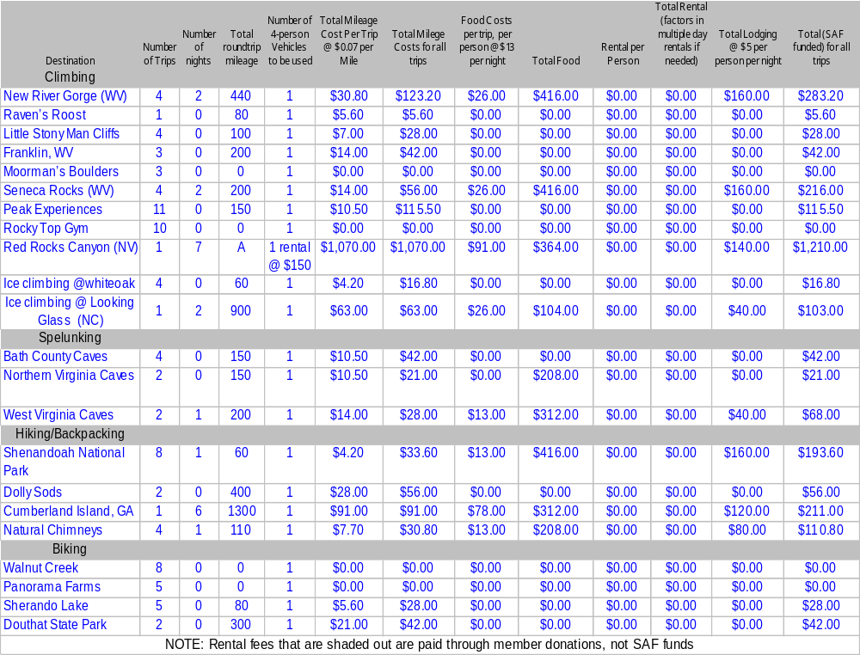
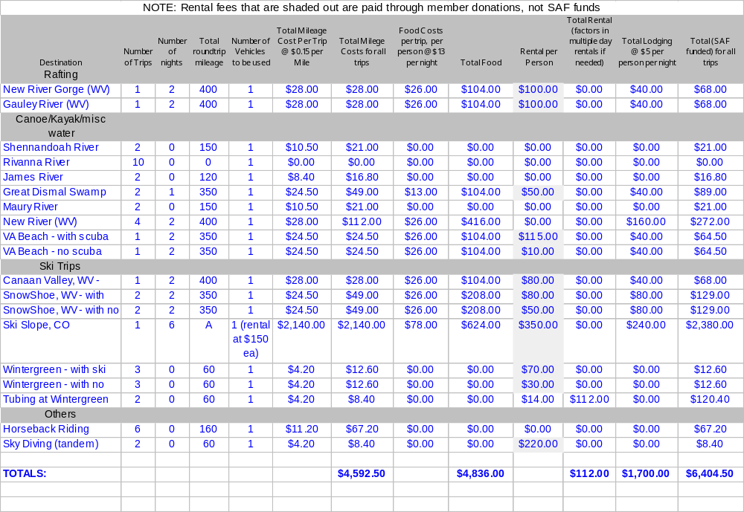
Part a: Total S.A.F. Fundable Expenditures

Equipment purchase: 10540.02
Because of the support of SAF funds, we have been able to ensure that club members are using safe and appropriate gear for our activities. As described previously, the number of trips has greatly increased over the last couple of years, and to a large extent this is due to the club’s ownership of a wide range of equipment. In order to ensure that the club continues to provide all types of activities to its members, we need to expand our equipment inventory. The areas of kayaking, climbing, skiing, and snowshoeing all require that the club purchases additional equipment.
Since several trips occur each week and members are allowed to borrow gear for up to one week, keeping track of gear is very important. The current system involves signing an agreement and listing the gear on a sheet in the gear room. When the gear is returned, an officer signs the sheet saying that the equipment was returned in the same condition as before. In order to greatly ease the task of tracking down missing gear and to allow trip leaders to know what gear is available in the gear room, a system of checking out gear on a computer in the gear roomwould be instrumental.. With an internet connection in the gear room, this database would be accessible from outside the gear room so that leaders could plan better and so that a computer program could send automatic reminders to members with gear checked out. Officers bought a fairly nice computer at one of the UVA auctions for thirty dollars, so now we just need an internet connection in order to get the online gear database up and running. We already have Excel sheets of all the club’s gear, and a couple of the officers would be able to set up the online system. The cost for the internet connection has been quoted to us from ITC as around $300.
Currently the club owns many pairs of wooden cross country skis that are older than the club’s members along with a couple of newer (but still old) skis. Because the numbers are limited and the boots do not cover a full range of sizes, members have not been able to participate much in cross country skiing. In the last two months, members have been disappointed during times of snow in Charlottesville that there were not enough functional skis or there was not an appropriate size boot for them. Very determined and set on skiing, one first year ventured out with two right foot boots since there were no other options. In addition to skiing around Charlottesville, opportunities abound in other areas, such as around Snowshoe, Canaan Valley, and in the Shenandoah National Forest. Club members have a high interest in this sport, and if equipped appropriately, they would be able to participate during the winter months. As many outdoor activities are limited during times of snow, having an additional eight pairs of cross country skis would increase the opportunities.
In addition to cross country skis, the club needs to buy more snowshoes. Currently the club owns only two nice pairs of snowshoes, which severely limits the number of members who can go out on snowshoes for day trips or for backpacking trips. With the purchase of four more pairs of snowshoes, members would be able to explore trails that are inaccessible in just hiking boots. Just as with cross country skis, snowshoes enable members to fully utilize the winter months.
Although much effort has been made to ensure that all trad, sport, and toprope climbing trips have the gear necessary for all participants, we do not have any ice climbing tools. We’ve had many requests for ice climbing from experienced ice climbers as well as beginners, but have had to turn them down because of the lack of gear. We know of no one else in this area that offers ice climbing, so this would definitely benefit the UVA community. Areas around Charlottesville surprisingly offer many places during the winter for this sport. While members could ice climb locally, farther destinations include West Virginia and places in the Northeast as well as North Carolina. With the proper gear, competent leaders could take members on ice climbing trips. Because the boots are expensive, we will only be getting three different sizes which should hopefully be able to accommodate a majority of the participants.
New kayaks and appropriate gear have enabled members to participate in this sport to a much greater degree than in years past. Although the club is fairly well stocked with boats for medium sized beginners, we need more variety in boats so that larger members can be accommodated, so that we can expand into creek boating, and so that more experienced boaters can improve their skills. The four boats listed below would increase the club’s boat diversity, allowing more people to participate in club ventures. It is especially important that we can place people in appropriately sized boats for safety concerns. If a person is in too small of a boat, for instance, the stability can be compromised and the risk of overturning greatly increased. In addition to more boats, the club needs to buy more safety gear and more gear for cold weather kayaking. In order to rescue a kayaker when he has come out of his boat and needs to reach the shore or escape a hole, throw ropes are used to drawn him in. Two throw ropes would allow club members to stay safe on the river during times of potential danger. Additionally, the club needs to buy a few more helmets so that every participant has one that fits appropriately. As for cold weather equipment, the wetsuits, skull caps, and gloves are essential in order to remain safe on the water on chilly days. Because of the popularity of kayaking, it has sometimes been difficult to transport the necessary number of boats just on the tops of cars. For this reason, a trailer would ensure that we were not limited in the number of boats that we could carry. While a trailer would probably be the most helpful for kayaking, it could also be used to transport bikes or other gear. Although the cost of a trailer seems high, it would last for many years and would ensure that more members could participate on trips.
All of the equipment we currently have and all that will be purchased next year is stored year round in the basement of Echols dorm. Officers have access to the room by checking out a key.
Note: if you want to edit the following equipment list, double click on it and it will open as an excel sheet. Changing a price, number of items, or removing things should cause the total to change automatically.
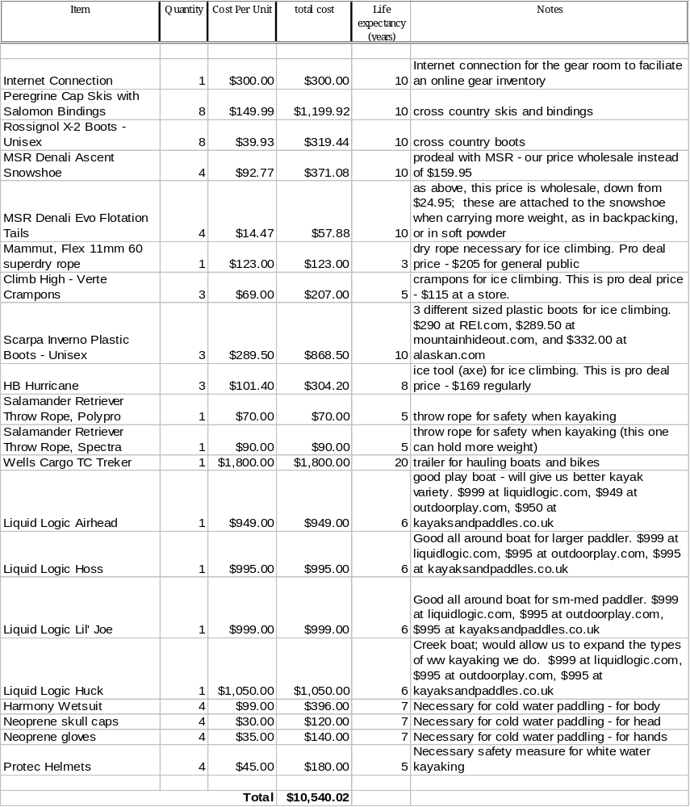Money allocated for Equipment Purchase for the 2003-2004 academic year: $ 3978.59
Money spent on Equipment Purchase for 2003-2004 academic year: $ 3492.87

Equipment repair: $683.02
Most of the equipment repair involves bike maintenance. Keeping the bikes in good condition ensures a long lifespan for the bikes and adds to the safety of the riders. Some funds are necessary for the general cleaning of sleeping bags, tents, and shoes.
Item | Quantity | Cost Per Unit | total cost | Notes
Performance ATB presta tube | 4 | 24.99 | 99.96 | replacement tubes in case ours get punctured
IRC Mythos XC ATB tire | 3 | 39.99 | 119.97 | replacement tire in case ours get damaged or worn
Performance Patch Kit | 4 | 6.99 | 27.96 | Patches to quick fix punctured tubes while riding
Pedros Maintenance Comp Kit | 2 | 22.99 | 45.98 | small kit to maintain bike's drive train
Pedros Super Pit Kit | 2 | 49.99 | 99.98 | big kit for general bike maintenance
Pedros Degreaser, 2 pack | 2 | 19.98 | 39.96 | need lots of degreaser for chain maintenance
White Lightning Lube/Clean Streak combo | 4 | 13.98 | 55.92 | need lubrication for chain, bearings, joints, etc to maintain bike
Pedros Syngrease with injector | 3 | 21.99 | 65.97 | need grease to prevent wear on bearings, fork, etc.
Pedros Ice Wax, 4 oz. Bottle 3 pack | 2 | 19.17 | 38.34 | Wax protects chain in severe conditions
Finish Line Super Clean Kit #3 + chain cleaner | 1 | 84.98 | 84.98 | All Purpose clean kit for general bike cleaning and maintenance; large volume for many uses or multiple bikes
Lysol disinfectant spray | 1 | 4 | 4 | Cleaning some gear

Money allocated for Equipment Repair for the 2003-2004 academic year: $ 240
Money spent on Equipment Repair for 2003-2004 academic year: $ 622

Equipment and Room Rentals: $90.
Although the club can generally provide participants with the necessary equipment, sometimes we have to rent items. This year we have had to rent various gear for trips, such as an extra tent and sea kayaks, and we have also rented items from UVA. In the beginning of each year we have a slide show of past trips during our informational meeting to recruit new members. In order to show the pictures, we have to rent a projector. We also have to pay for our mailbox at Newcomb which members use to drop off dues and liability waivers.
Item | Quantity | Cost Per Unit | total cost
LCD Projector | 1 | $50.00 | $50.00
Extra gear for large trips (tents, climbing shoes, sleeping bags) | 5 | $8 | $40
Money allocated for Equipment and Room Rentals for the 2003-2004 academic year: $ [$0.00]
Money spent on Rentals for 2003-2004 academic year: $ 499.27

Speakers expenses (not including honoraria): $60
This year Outside Magazine is paying for professional climber Timmy O’Neil to give a show to the school. We still need to pay for Timmy’s lodging though. We hope to have another show like this next year, however the specifics we don’t know about yet
Speaker Breakdown:
Name: | Airfare | Total mileage | mileage Reimb. (@ $0.25 per mile) | Meal Costs ($20/ Day) | Lodging ($60/ Night | total cost For Speaker
? Whoever Outside Magazine brings ? | - | - | - | $20 | $60 | $80
(Note: To insert more rows, move the cursor to the right of the asterisk (*) above, press right arrow button once then press enter)
Money allocated for Speakers Expenses for the 2003-2004 academic year: $ [$0.00]
Money spent on Speakers Expenses for 2003-2004 academic year: Possibly around $60 (show is in april)

honoraria: $0
Money allocated for Telephone for the 2003-2004 academic year: $ 0
Money spent on Telephone for 2003-2004 academic year: $ 0

Advertising: $0
Money allocated for Advertising for the 2003-2004 academic year: $ 0
Money spent on Advertising for 2003-2004 academic year: $ 0

Member Travel: 6292.5
Outdoors at UVA relies on members to provide transportation. The only exception to this is the two planned spring break trips to Colorado and Nevada, where a plane and rental car will be utilized.
Almost all of our lodging is in campground areas, sleeping in tents. Since we own the tents, we only have to worry about campsite fees. These range from place to place, but most either charge $5 per person or a flat fee for each site. The only exceptions to sleeping in tents are the ski trips. For these, we rent out relatively cheap houses that can sleep upwards of 20 people in each house. We are able to accomplish this by having people sleep on the floor in sleeping bags provided by the club.
Aside from the normal gas money paid to drivers, we anticipate 3 spring break trips which are going long distances. For the trip to Cumberland Island, we anticipate 2 cars going about 1300 miles. For the two trips out west, we are looking for SAF funds to pay for plane tickets, as well as rental cars, estimating that each plane ticket will cost ~$230.
The total breakdown of where the member travel expenses are coming from can be seen in the above excel sheet under “2004-2005 Trips, Rentals, Travel, Donations.”
The club also does not reimburse drivers for distances less than 40 miles round trip, and for trips over 40 miles, the club usually reimburses at a rate of $.07/mile, depending on what type of vehicle is being driven, and what the current gas price is.
Money allocated for Member Travel for the 2003-2004 academic year: $ 9742.75
Money spent on Member Travel for the 2003-2004 academic year: $ 3225.6 (will double after spring break)

National dues and Registration Fees: $1029
The club purchases about 8 yearlong passes to the Shenandoah National Park for trip leaders who plan on going there more than twice, and 4 or so day passes for people who we only expect to go to the park once. The Red Rock pass is for the spring break climbing trip.
While the club provides basic gear for members, members pay thousands of dollars each year to cover rentals of things that the club does not own and cannot cover. Whitewater rafting trips, for instance, involve guide and raft fees, and skiing trips require fees for ski rentals. Because these fees are relatively high and since many members have their own equipment, like skis, the club does not cover these costs. However, we are asking for funds to help cover the costs of snow tubing. These fees are relatively low per person, and since no one already has the equipment themselves, we feel as though the club should help pay for the rental. The horseback riding fee is a per person fee for a guided horseback ride that lasts several hours. Although these are outlined above in the first spreadsheet of the planned trips, they are presented below for clarity.

Item | Quantity | Cost Per Unit | total cost
Shenandoah National Park Pass | 8 | $20.00 | $160.00
Shenandoah National Park Pass | 4 | $10.00 | $40.00
Red Rocks Canyon National Park Pass | 1 | $20 | $20
Newcomb Hall Mailbox fee | 1 | $15 | $15
Fall Activities Fair | 1 | $10 | $10
Horseback riding fees | 48 | $14.00 | $672.00
Snow Tubing fees | 16 | $14.00 | $112
Money allocated for Registration Fees for the 2003-2004 academic year: $ 25
Money spent on Registration Fees for 2003-2004 academic year: $804

Office Supplies: $0
Money allocated for Office Supplies for the 2003-2004 academic year: $ [$0.00]
Money spent on Office Supplies for 2003-2004 academic year: $ [$0.00]

Postage: $18.70
We send on average 10 checks to reimburse members by mail sometime. Normally each year we will need to end up mailing some equipment (normally heavy) for service.
Itemized List:
Item | Quantity | Cost Per Unit | total cost
Reimbursements | 10 | $0.37 | $3.70
Repair (equipment) | 1 | $15.00 | $15.00
Money allocated for Postage for the 2003-2004 academic year: $ 0
Money spent on Postage for 2003-2004 academic year: $ 17.41

Copying: $10
Liability waivers are for nonmembers who just want to go on one trip, as well as for when we sign up lots of new members all at once, since waiting for the printer to print out 80 pages would take too long. Equipment forms are used to keep track of who borrowed what. Flyers, which contain directions on how to join through the website as well as listing some things we do, are handed out during activities fairs.
Item | Quantity | Cost Per Unit | total cost
Liability Waivers for nonmembers | 200 | $0.01 | $2.00
Equipment | 200 | $0.01 | $2.00
Flyers to hand out during activities fair (~4 flyers per page) | 600 | $.01 | $6.00
Money allocated for Printing and Copying for the 2003-2004 academic year: $7.00
Money spent on Printing and Copying for 2003-2004 academic year: probably $5

Publishing: $0
Money allocated for Publishing for the 2003-2004 academic year: $ 0
Money spent on Publishing for 2003-2004 academic year: $ 0

Telephone: $0
Money allocated for Telephone for the 2003-2004 academic year: $ 0
Money spent on Telephone for 2003-2004 academic year: $ 0

Miscellaneous: $0
Part B: Non-Fundable (Out of Pocket) Expenditures

Social: $210
The club will continue to subsidize trips to Ben & Jerry’s for ice cream, as well as a Potluck supper every semester.
Item | Quantity | Cost Per Unit | total cost
Ben & Jerry’s Ice Cream Socials | 2 | $60.00 | $120.00
Potluck Suppers | 3 | $30 | $90
Money budgeted for social expenses for the 2003-2004 academic year: $ 360
Money spent on social expenses for 2003-2004 academic year: $150

FundRaising Expenses: $0
The shirts cost us nothing.
Money budgeted for fundraising expenses for the 2003-2004 academic year: $ 0
Money spent on fundraising expenses for 2003-2004 academic year: $ 0

Other Expenses: $23550
Food is obviously a necessary constraint for overnight trips. We calculate that on average we spend $13 per person per day on food. That translates to two meals: $8 for dinner and $5 for breakfast. Members pay for half of the food and club dues cover the other half.
Itemized List:
Item | Quantity | Cost Per Unit | total cost
Food per person per day. | 820 | $13 | $10660
Member donations, rentals |  |  | 12890
(Note: To insert more rows, move the cursor to the right of the asterisk (*) above, press right arrow button once then press enter)
Part C: Non-SAF Funds (self Generated Revenues)

Membership Dues: $13200
In order to be a member of the Outdoors club, one is required to either pay a semester or yearly membership due. Members are given $30 “club bux” if they have a full membership, or $20 “club bux” if they have a semester membership. Club bux come from member dues and are used to pay the trip participation fee (this fee goes directly to paying off the trip costs). Once there are no more club bux, real cash must be used.
Full year membership is $35 and one semester is $25.
We expect to have about 380 members this year (currently we are at 347 and last year we only had 333 members by the end of the summer semester) and expect 375-425 members next year.
Itemized List:
category | Number | Amount | income
Full year dues | 320 | $35.00 | $11200
1 semester dues | 80 | $25.00 | $2000
Predicted dues revenue for the 2003-2004 academic year: $ 12,605.00
Actual dues money collected for 2003-2004 academic year: $ 11,705.00

Donations: $18,740.00
Membership donations are a large part of what make the club work. The club goes to a climbing gym at least once a week during the winter, and members pay for their admittance fee (around $7-9 usually). These indoor climbing trips average about 10 people per trip. The club also goes on ski trips, where neither the rental of skis, nor the lift tickets are paid for by the club, so they are paid for out-of-pocket. Most trips are free, unless they are overnight, in which case they usually cost each member $5 per night for food. Furthermore, if we do not receive enough funding to pay for airfare to CO or NV, then members will pay for the airfare out of pocket, adding a substantial amount of donations
See next page for list:
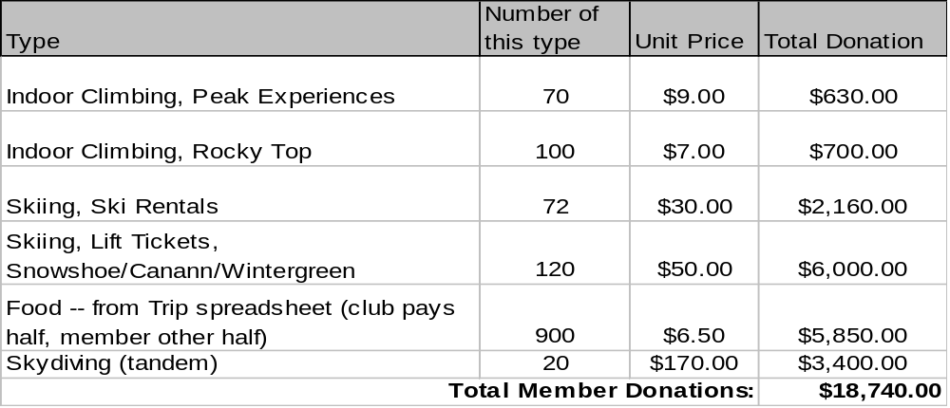
Predicted donations for the 2003-2004 academic year: $ [$0.00]
Actual donations received for 2003-2004 academic year: $ 6933

Fundraising Revenue: $205.50
The club has begun actively trying to fundraise. This year we have printed our first shirts, and next year we intend to print another batch, as new members join and the demand grows.
Itemized List:
Item | Quantity | Income Per Unit | total Income
T-Shirts | 75 | 2.74 | $205.50
(Note: To insert more rows, move the cursor to the right of the asterisk (*) above, press right arrow button once then press enter)
Predicted fundraising receipts for the 2003-2004 academic year: $ 150
Actual fundraising receipts for 2003-2004 academic year: $ 114.36

Financial Account Information
SAF Allocation for the 2003-2004 Academic Year: $7067.47
Total Financial Holdings as of the end of the Fall 2003 Semester: $7842.64, 1-1-2004
Projected Financial Holdings as of the end of the Spring 2004 Semester: $$500.00 - $1,000.00 (we continue on in the summer with trips)
Thank you for your cooperation in the Spring 2004 Appropriations Process! Please direct any comments, suggestion or questions to your committee member or to Connor Fee and Leo Yanez, Appropriations Committee co-chairs at:
cio-appropriations@virginia.edu.

